Analysis of Gun Violence and Mass Shootings in the United States
  - Analysis of gun violence at the country level followed by a deeper analysis
  - at the city level (Chicago, Illinois)

Nirbhay Ashok Pherwani
Information Sciences and Technologies
Rochester Institute of Technology
Rochester New York USA
np5318@rit.edu

ABSTRACT
There has been an up rise in the number of gun violence related incidents in the past few years. According to an article published by CBS [1] there were more mass shootings than days in the United States in 2019. The analysis helps in answering the following questions Which are the regions most affected by mass shootings and gun violence in the United States in the past three years. On selecting one such region answering the question of what kind of effect did it have on the population involved in terms of number of casualties (killings plus injuries), relating to the number of weapons used in gun violence incidents in the area. Is there a need for more control resources like police stations and hospitals in such an area? How efficiently can we use Geographic Information Systems to create evacuation-based routing strategies to nearby emergency services beforehand in case of more such incidents. Data was obtained from the gun violence archive (GVA) [2] and sourced from an open source repository on GitHub [3]. Incidents from December 2016 to 2019 were chosen for the analysis. A hotspot analysis (Getis-Ord Gi* statistic) was conducted on this data to identify regions of statistically significant hotspots and cold spots of gun violence incidents in the United States. The focus was then shifted to one such region, in our case that being Chicago, Illinois. After which regions of impact in Chicago are mapped by creating hot zones using a heat map. The focus then further shifted to the Central Chicago Area. On proportionally comparing the number of casualties to the number of guns involved in gun violence incidents in Central Chicago showed that the numbers can be uneven and there is no relation between the two variables under consideration. Furthermore, after adding data for police stations and hospitals in the Central Chicago area there seems to be a need for more control resources (if not complete placement at least patrolling resources) especially due to the presence of many schools and work areas in the region. Finally, an evacuation routing strategy is shown for a scenario where a school is under distress and needs to reach the nearest emergency control resource (a hospital followed by a police station). This was achieved using Routes in Network Analyst in ArcGIS Pro. Results of the analysis have been presented using cartography principles by creating insightful maps that answer all the questions mentioned above. Through this study we also see that use of GIS in such an analysis can prove to be very effective and can be very helpful in preventing and controlling such future incidents and in identifying high-risk areas [4]. It can also be extended to other similar studies and can matter a lot in decision making and strategizing [4].
Permission to make digital or hard copies of part or all of this work for personal or classroom use is granted without fee provided that copies are not made or distributed for profit or commercial advantage and that copies bear this notice and the full citation on the first page. Copyrights for third-party components of this work must be honored. For all other uses, contact the owner/author(s).
© 2018 Copyright held by the owner/author(s)
CCS CONCEPTS
- Information systems Information systems applications Spatial-temporal systems Geographic information systems
KEYWORDS
Gun Violence, Mass Shootings, Hotspot Analysis, Heat Mapping, Scenario Based Routing Strategies, Violence Suffered Victims.
- INTRODUCTION
There has been an up rise in the number of gun violence related incidents in the past few years. According to an article published by CBS [1] there were more mass shootings than days in the United States in 2019. Another article published in “The Trace” mentions that the annual cost of gun injury hospitalization is 911 million dollars. This problem of gun violence has continued to remain a problem since the last 10 years with the numbers showing an up rise too thus demanding for the need of better strategies and additional control resources in areas with high incidences as well as in areas with high number of casualties.
- PROBLEM DESCRIPTION
Firearm related violence is one of the most pressing criminal justice problems in America [5]. 2019 had the highest number of mass shootings in any year since 2014 [1]. Gun violence in the United States is a major problem and it is important to take measures and form strategies beforehand especially in areas where the chances of this happening again are very high. To figure that out we need to find answers to questions like, which are the regions most affected by mass shootings and gun violence in terms of number of people killed and injured? What kind of effect did it have on the population involved in terms of number of casualties (killings plus injuries), relating to the number of weapons used in gun violence incidents in the region? Is there a need for more control resources like police stations and hospitals in such a region? How efficiently can we use Geographic Information Systems to create evacuation-based routing strategies to nearby emergency services beforehand in case of more such incidents. Answering these questions by looking at the incidents at an abstract level in the country as well as at a more concrete level in a city is the focus of this analysis.
- GOALS AND OBJECTIVES
The aim for this analysis was to find answers to the questions mentioned in the problem description along with creating scenario based evacuation routing plans in a particular area in the country (in our case that being Central Chicago Area, Illinois) and finally visualize the results obtained through maps using cartographic principles. The goals were achieved by keeping the following objectives in mind.
- Identify the regions which are most affected in terms of number of people killed and injured using hotspot analysis.
- Construct a heat map for a selected region (Chicago, Illinois) and identify a sub area to study (Central Chicago Area, Illinois).
- Justify the need for more control resources like hospitals and police stations by using mapping techniques.
- Use proportional symbols to compare and display the relation between casualties and number of weapons involved in gun violence incidents in the chosen area.
- Showcase the importance of Geographic Information Systems for creating emergency evacuation-based routing strategies to hospitals and police stations using a scenario (In our case, a school under distress due to gun violence in the neighborhood) and Routing in Network Analysis (ArcGIS Pro).
- LITERATURE REVIEW
In a paper on “GIS Crime Mapping to Support Evidence-Based Solutions [7]”, it’s said that Geographic Information Systems (GIS) can be used very effectively in helping create evidence-based solutions like mentioned in the article on GIS Crime Mapping [7]. In the paper, the authors’ focus was the identification of spatial trends in gun-related crimes during 2012 to 2017, along with identifying patterns before and after the introduction of safe passage routes in four areas in Chicago they studied about [7]. Their study revealed that hotspot trends for gun-related crimes have intensified in most of the communities in these areas, which include school zones and safe passage routes [7].

In another article about “The Philadelphia Foot Patrol Experiment [8]”, the results showed the effective contribution of hotspots in place‐based policing resulting in reduction of crime, and especially violent crime, which is a significant public health threat in the United States [8].

Another paper on “Marked point process hotspot maps for homicide and gun crime prediction in Chicago [9]”, which discusses an enhanced strategy for mapping hotspots, mentioned that crime hotspot maps are a widely used and successful method of displaying spatial crime patterns and allocating police resources [9].

After reviewing the articles and the results presented, it seemed interesting to follow a similar approach to answer the questions listed in the problem description and also check to see if they would justify the need for better strategies in terms of evacuation as well as better placement of control areas (like police stations) especially where the intensity was high.

5. DATASETS AND METHODOLOGY
5.1 Data Collection and Processing
Data on the gun violence incidents in the United States was obtained from The Gun Violence Archive (GVA) [2] and source from an open source GitHub repository [3]. The data was available as a tar archive. It contained the data in (.CSV) format. The data consisted of gun violence incidents from 2013 to 2018. This data was imported into the ArcGIS project. It contained 239,677 records. It had fields for date, number of killings, number of people injured, number of guns used in an incident, etc.

This data was then converted to XY data points and exported as a feature layer in ArcGIS Pro. For the purpose of this analysis records after December 2016 were used. To extract data after December 2016 a SQL operation using the “date” filed was performed on the created feature layer using the “Export Features” tool in ArcGIS Pro to create another feature layer for Crime Incidents after 2016. The number of records now were reduced to 75,203.

In addition to this data for hospitals, police stations and schools in the United States was obtained from the ArcGIS online search tool [10] and added as feature layers in the project.

For the focused analysis in the Central Chicago Area, for the purpose of filtering the data options like “Select by Location”, “Select Rectangle”, “Copy Features” were used to export data as feature layers. ArcGIS Pro software was used to perform the analysis and visualize the results.

5.2 Methods Used
5.2.1 Hotspot Analysis
For the purpose of understanding the areas affected due to gun violence incidents based on the number of casualties (number of killings and number of people injured) Getis-Ord Gi* statistic was used to find the locations of hotspots of the incidents. This was conducted using ArcGIS Pro Software.

Statistically significant spatial clusters of high and low values (hot and cold spots) were identified using the Getis-Ord Gi* statistic [4, 11]. The Getis-Ord Gi* returns a Z-score which indicates the degree of a location surrounded by areas with similar number of cases. The Z-scores >1.96 represent statistically significant hotspots at the 95% confidence level, while those <-1.96 are statistically significant cold spots at the 95% confidence level [4, 11].

5.2.2 Heat Mapping
For the purpose of identifying an area to target within the selected region after performing the hotspot analysis, heat mapping was used. Heat mapping is a symbology technique that can be used “when we have many points that are close together and cannot be easily distinguished [12]” as would be in the case of a highly crime incident area.

Heat Mapping uses Kernel Density in the background to construct the heat map raster with a color scheme that has a smooth variation of a set of colors, ranging from cool (sparse density of points) to hot (high density of points) [12].

Every cell in the constructed raster visualization represents a relative density value [12]. This density by default uses the feature count, but the analysis uses the number of casualties (number of people killed plus the number of injuries) to weight the density by an attribute instead.

5.2.3 Proportional Symbology
Proportional symbology is used to show relative differences in quantities among features [13]. For the purpose of justifying the need for additional control resources (police stations and hospitals) the proportional symbology technique was used to showcase the number of incidents weighted by the number of guns involved in the incidents.

Furthermore, data obtained for police stations and hospitals was included to justify the need for more resources and if not at least patrolling placements.

In addition to this, proportional symbology was also used to compare and display the relational differences between casualties as a weighted attribute and then number of weapons involved in gun violence incidents as a weighted attribute in the chosen area. Both the feature layers (which were initially a copy of the chosen area’s crime incidents) were symbolized and compared for the selected region (obtained after heat mapping) with their respective weighted attribute.

5.2.4. Routing with Network Analysis
The ArcGIS Network Analyst tool can be used to find the best way to get from one location to another or to visit several locations [14], even when you have obstructions to avoid on the road.

Routing with Network Analysis was used for showcasing a scenario-based evacuation strategy by creating stops (school, hospital, police stations), point, line and polygon barriers caused by gun violence incidents.

After which running the route analysis, a safe route from the school to the other stops avoiding the barriers was to be created to showcase the capabilities of Geographic Information Systems for creating emergency evacuation-based routing strategies.

6. RESULTS
6.1 Selected Data
Here the data obtained from Gun Violence Archive (GVA) [2, 3], after being filtered to extract data points after 2016 is being displayed using a map. This is the data on which the analysis has been performed.

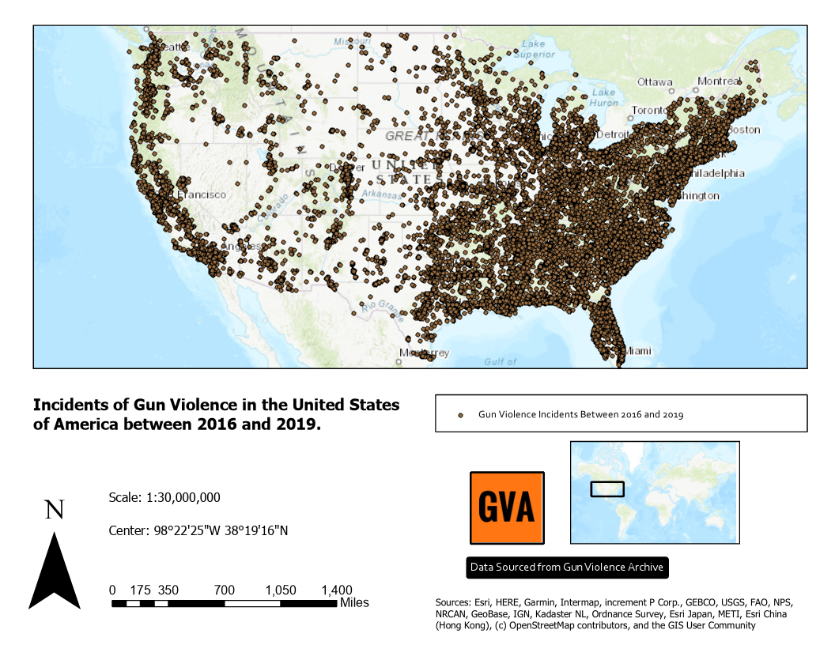
Figure 1: Incidents of Gun Violence in the United States of America between 2016 and 2019 (75,203 Records)
Figure 1 provides us with an impression of the vast number of crime incidents in the United States and clearly gives us reason to work on our goals and objectives listed.

6.2 Hotspot Analysis of Gun Violence Incidents in the United States of America
In order to identify statistically significant spatial clusters of high values of gun violence incidents (hot spots) and low values of gun violence incidents (cold spots), hot spot analysis of gun violence cases between 2016-2019 was carried out by the Getis-Ord Gi* statistic in ArcGIS Pro.

Figure 1 justifies the need for performing an analysis to identify affected regions in the country. With the data available to us, there were two options, either to perform our hotspot analysis based on number of incidences in a location or the number of casualties (killings plus injuries). Based on the reason that human lives are more important to analyze than number of incidents in a location, the analysis was taken forward by conducting the hotspot analysis with number of casualties as the input field to be considered.

From the results of the hotspot analysis in Figure 2, it can be seen that statistically significant hotspots of Gun Violence Incidents based on number of casualties were seen in several regions in Eastern America and Southern California.

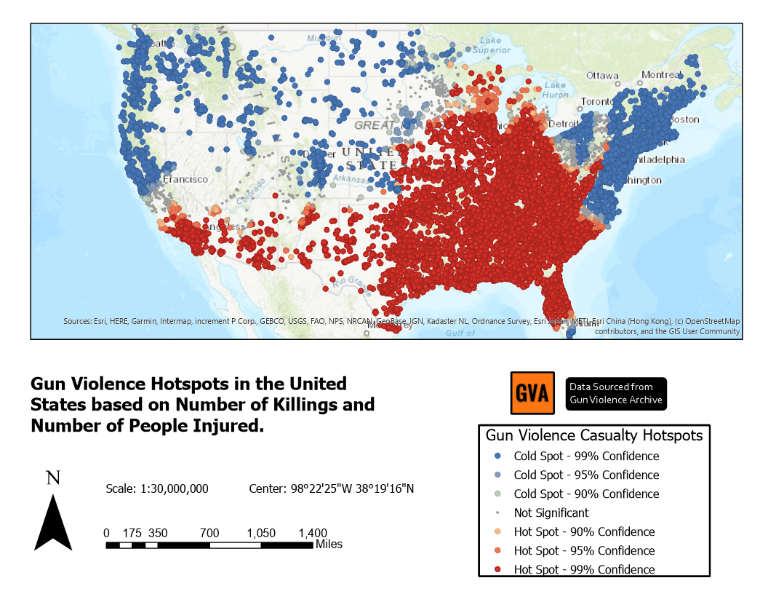
Figure 2: Hotspots of Gun Violence Incidents based on Number of Killings and Injuries in the United States.
As there were several options to choose from, seeing that Chicago, Illinois was spending approximately 2.5 billion dollars on medical expenses due to violent crimes every year [6], it was chosen as the city to be further analyzed.

6.3 Heat Mapping of Gun Violence Incidents in Chicago, Illinois
For the purpose of identifying an area to target within the selected region after performing the hotspot analysis, heat mapping was used. As Chicago is big, the decision to use a symbology technique like heat mapping helped in determining a more focused location to analyze. Here too the number of casualties were used as a weight attribute for creating the heat map.
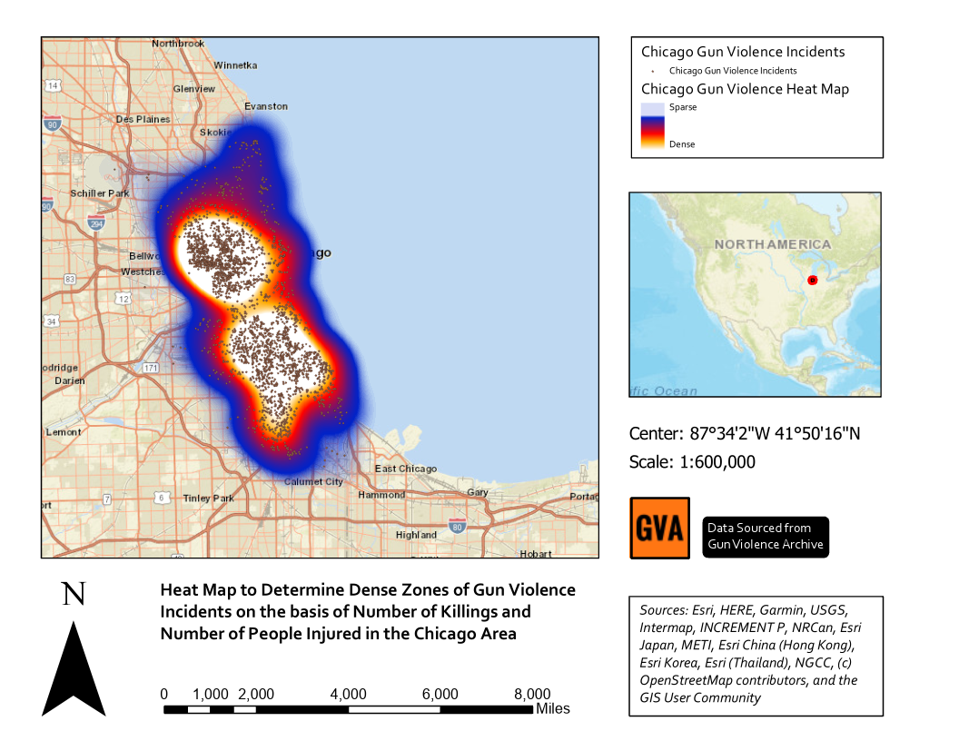
Figure 3: Heat Map to Determine Dense Zones of Gun Violence Incidents based on Casualties in the Chicago Area.
As we can see in Figure 3 there are two major centers of dense incidence created. A legend is provided to help recognize sparse and dense regions of incidence. The analysis is taken forward by choosing the Central Chicago Area as the location to be considered for further analysis.

6.4 Placement of Control Resources in the Central Chicago Area Relative to Past Gun Violent Sites
Proportional Symbology was used to showcase the number of incidents weighted by the number of guns involved in the gun violence incidents in Central Chicago. Over which data obtained for police stations and hospitals was included to identify a need for more emergency services in the area.
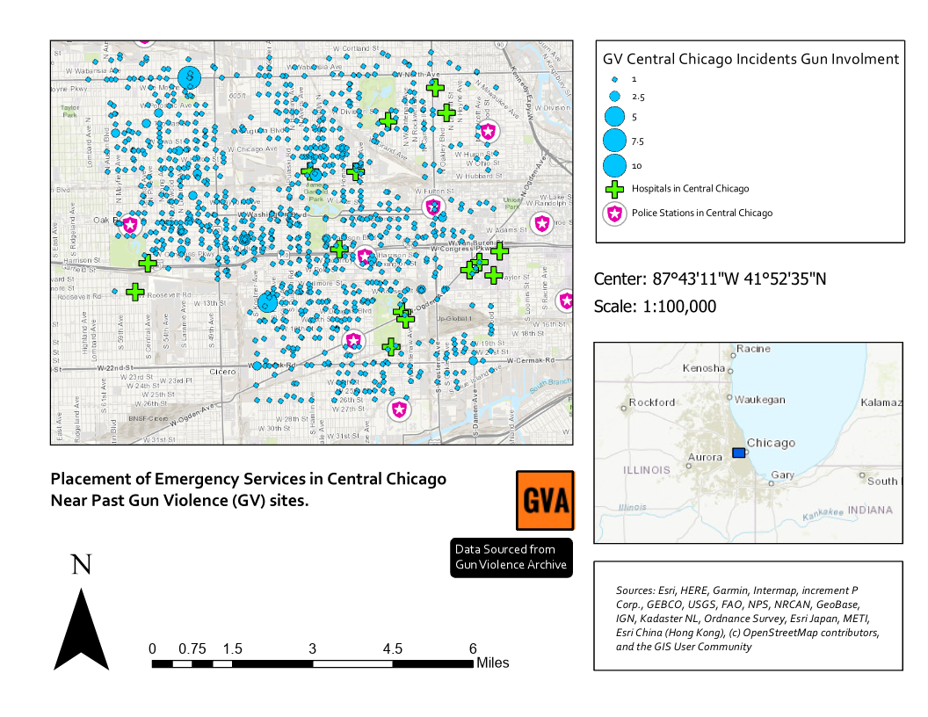
Figure 4: Placement of Emergency Services in Central Chicago Near Past Gun Violence (GV) Sites.
From the map in Figure 4 we can see that it would not hurt to have some additional resources in the north western part of Central Chicago. And if not at least more additional patrolling placements if it is not already the case. The article on “The Philadelphia Foot Patrol Experiment [8]” talks more about this strategy.

6.5 Number of Casualties vs Gun Violence Incidents Weighted by Number of Guns Involved
Proportional symbology was also used to compare and display the relational differences between casualties as a weighted attribute versus number of weapons involved in gun violence incidents as a weighted attribute in the Central Chicago Area.
As we can see from Figure 5, it is not necessary that the number of casualties caused in an area are directly proportional to the number of guns involved in the incident. There are places (like North West Area of Central Chicago) where the gun involvement
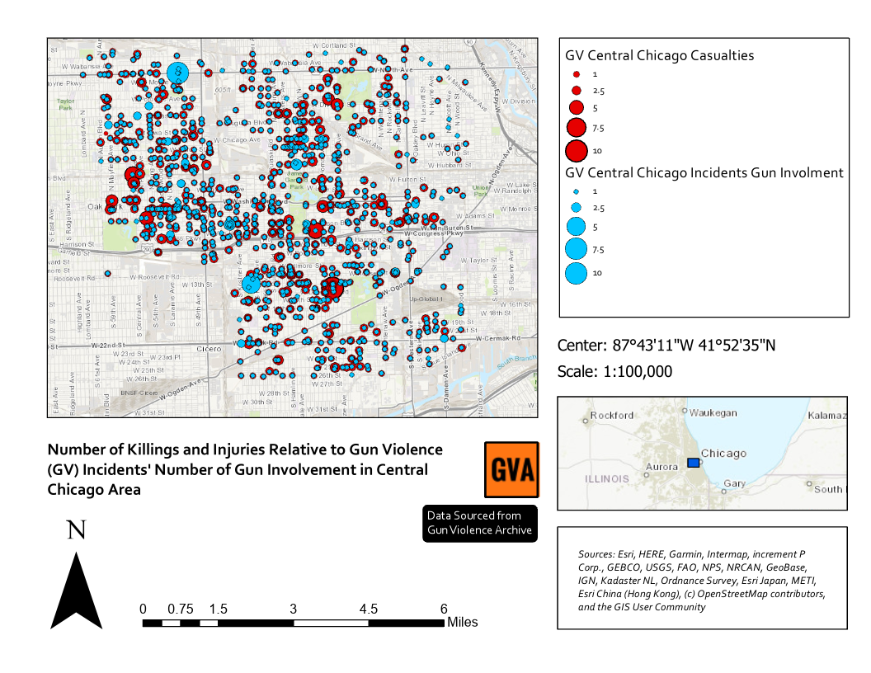
Figure 5: Number of Killings and Injuries Relative to Gun Violence (GV) Incidents’ Gun Involvement in Central Chicago Area
in incidents has been high, but the casualties haven’t. At the same time the opposite holds true (South East Area of Central Chicago).

6.6 Emergency Evacuation Strategy for a School in Distress due to Gun Violence in the Neighborhood
In order to showcase the importance of Geographic Information Systems for creating emergency evacuation-based routing strategies to nearby control centers (police stations and hospitals) “A School in Distress” scenario was created using Routing with Network Analysis in ArcGIS Pro.
The school in distress was supposed to transport children from the school to nearest emergency centers (a hospital followed by a police station), due to several concurrent gun violence zones in the surrounding neighborhood.
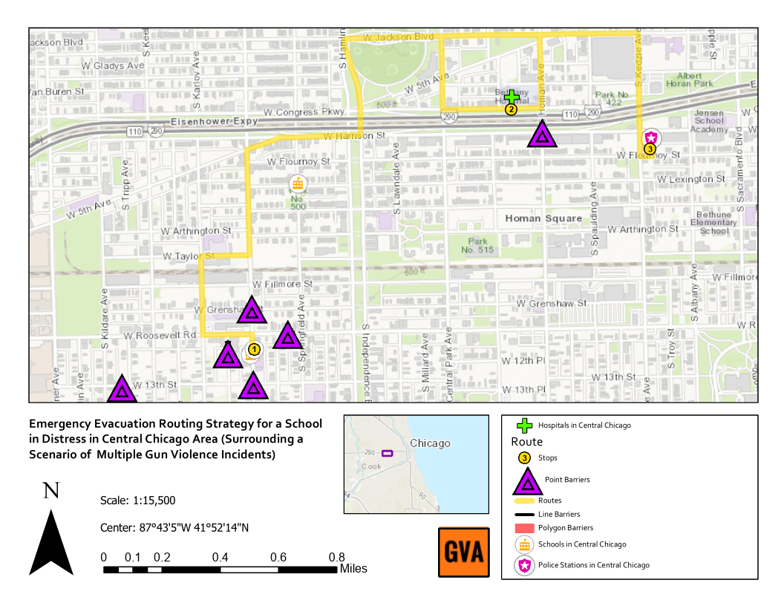
Figure 6: Emergency Evacuation Routing Strategy for a School in Distress (Surrounded by Concurrent GV Incidents)
Routing with Network Analysis was used by first creating stops (the school, hospital, police stations), point (violet in legend (Figure 6)), line and polygon barriers caused by gun violence incidents in the surrounding area.
After which the route analysis was run, and a safe route (yellow in the legend (Figure 6)) from the school to the other stops avoiding the barriers was constructed as a result; of the route analysis as can be seen from Figure 6.
7. SUMMARY
The analysis of gun violence incidents in the United States helped in answering several questions that were raised earlier. Data was obtained from the gun violence archive (GVA) [2] and sourced from an open source repository on GitHub [3]. Incidents from December 2016 to 2019 were chosen for the analysis. A hotspot analysis (Getis-Ord Gi* statistic) was conducted on this data to identify regions of statistically significant hotspots and cold spots of gun violence incidents in the United States. The focus was then shifted to one such region, in our case that being Chicago, Illinois. After which regions of impact in Chicago were mapped by creating hot zones using a heat map. The focus then further shifted to the Central Chicago Area. On proportionally comparing the number of casualties to the number of guns involved in gun violence incidents in Central Chicago showed that the numbers can be uneven and there is no relation between the two variables under consideration. Furthermore, after adding data for police stations and hospitals in the Central Chicago area there seems to be a need for more control resources (if not complete placement at least patrolling resources) especially due to the presence of many schools and work areas in the region. Finally, an evacuation routing strategy is shown for a scenario where a school is under distress and needs to reach the nearest control resource (a hospital followed by a police station). This was achieved using Routes in Network Analyst in ArcGIS Pro. Results of the analysis have been presented using cartography principles by creating insightful maps that answer all the questions mentioned above.
8. CONCLUSION
This kind of analysis can be useful to identify high risk zones and help in strategizing, planning and justifying the need of additional control resources in such areas.

Through this study we also see that use of GIS in such an analysis can prove to be very effective and can be very helpful in preventing and controlling such future incidents and in identifying high-risk areas [4]. It can also be extended to other similar studies and can matter a lot in decision making and strategizing [4].
9. FUTURE WORK
It would be interesting to see how the analysis would pan out when considering more data points like the age group, gender and race of victims.
Secondly, manipulate data according to a unit of time (Weekdays and Weekends or Spring, Summer, Fall) and perform the analysis again to see if there is a significant change in the hotspot analysis.

10. REFERENCES
[1] Jason Silverstein. 2020. There were more mass shootings than days in 2019. (January 2020). Retrieved March 1, 2020 from https://www.cbsnews.com/news/mass-shootings-2019-more-than-days-365/
[2] Anon. Gun Violence Archive. Retrieved March 1, 2020 from https://www.gunviolencearchive.org/
[3] Anon. jamesqo - Overview. Retrieved March 1, 2020 from https://github.com/jamesqo/
[4] Nirbhay Ashok Pherwani. 2019. Analyzing H7N9 and H5N1 Influenza Cases. (October 2019). Retrieved March 1, 2020 from https://github.com/nirbhayph/Geographic-Information-Sciences-and-Technologies-RIT/blob/master/Week 7/Analyzing H7N9 and H5N1 Influenza Cases.pdf
[5] Arthur L. Kellermann, Dawna Fuqua-Whitley, and Constance Parramore. 2002. Community Problem-Solving to Reduce Juvenile Gun Violence: Atlantas Experience. PsycEXTRA Dataset (2002). DOI:http://dx.doi.org/10.1037/e501692006-001
[6] Anon. 2020. Crime in Chicago. (February 2020). Retrieved March 1, 2020 from https://en.wikipedia.org/wiki/Crime_in_Chicago
[7] Byungyun Yang. 2019. GIS Crime Mapping to Support Evidence-Based Solutions Provided by Community-Based Organizations. Sustainability 11, 18 (June 2019), 4889. DOI:http://dx.doi.org/10.3390/su11184889
[8] J.w. Carter. 2012. The Philadelphia Foot Patrol Experiment: A Randomized Controlled Trial of Police Patrol Effectiveness in Violent Crime Hotspots. Policing: An International Journal of Police Strategies & Management 35, 1 (February 2012). DOI:http://dx.doi.org/10.1108/pijpsm.2012.18135aaa.002
[9] George Mohler. 2014. Marked point process hotspot maps for homicide and gun crime prediction in Chicago. International Journal of Forecasting 30, 3 (2014), 491–497. DOI:http://dx.doi.org/10.1016/j.ijforecast.2014.01.004
[10] Anon. Browse and search content. Retrieved March 1, 2020 from https://doc.arcgis.com/en/arcgis-online/reference/search.htm
[11] Anon. How Hot Spot Analysis (Getis-Ord Gi*) works. Retrieved March 1, 2020 from https://pro.arcgis.com/en/pro-app/tool-reference/spatial-statistics/h-how-hot-spot-analysis-getis-ord-gi-spatial-stati.htm
[12] Anon. Heat map symbology. Retrieved March 1, 2020 from https://pro.arcgis.com/en/pro-app/help/mapping/layer-properties/heat-map.htm
[13] Anon. Proportional symbols. Retrieved March 1, 2020 from https://pro.arcgis.com/en/pro-app/help/mapping/layer-properties/proportional-symbology.htm
[14] Anon. ArcMap. Retrieved March 1, 2020 from https://desktop.arcgis.com/en/arcmap/latest/extensions/network-analyst/types-of-network-analyses.htm

11. APPENDIX
Visit following pages to view the appendix.

APPENDIX

